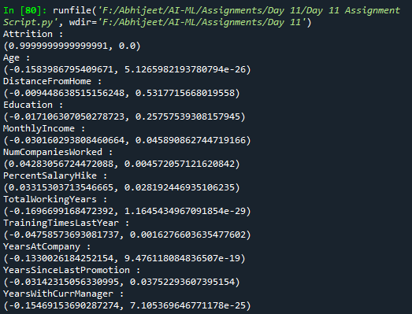Upon running the [Day 11 Assignment Script.py](Day%2011%20Assignment%20Script.py) script, we get the following output:

This shows that Attrition is only significantly correlated to:

* Age (Negatively correlated)
* Total Working Years (Negatively correlated)
* Years At Company (Negatively Correlated)
* Years With Current Manage (Negatively Correlated)

**Key:**

0 is No Attrition, 1 is Attrition.

Positive correlation: Higher value 🡪 Attrition

Negative correlation: Higher Value 🡪 No Attrition

So, with Higher Age, Experience, Time at company and Time with current manager, attrition rate decreases

Rest of the other columns don’t have significant correlation with Attrition